Task 1: [4 marks]
- Modify your Multinomial Naïve Bayes (MNB) classifier from Etivity5, Task 2, to train and test a sentiment classifier. [0.5 mark]

def multinomialNaiveBayesClassifier(trainingSet,testSet):
YOUR CODE HERE

trainingSet = [('Boxing scene was a disappointment','-'),('No plot twists or great scenes','-'),('Great satire and great plot twists','+'),('Great scenes a great film','+')]
testSet = [('Great disappointment indeed','?')]
multinomialNaiveBayesClassifier(trainingSet,testSet)

Expected Output:
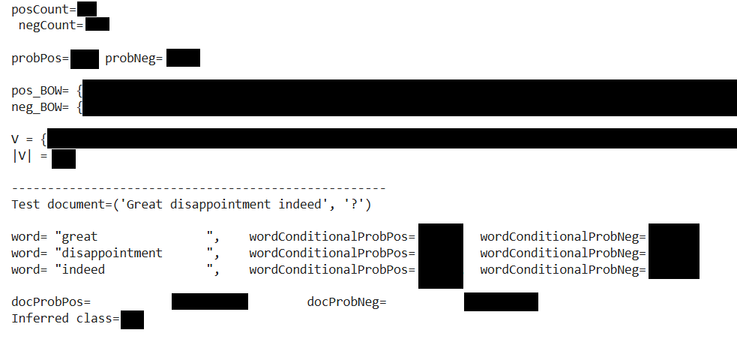

- Copy your solution for (a) into a new code cell. Modify your code to optimise it for the task of sentiment analysis, i.e., change your classification algorithm from MNB to BMNB (Binary Multinomial Naïve Bayes). [2 marks]

def binaryMultinomialNaiveBayesClassifier(trainingSet,testSet):
YOUR CODE HERE

trainingSet = [('Boxing scene was a disappointment','-'),('No plot twists or great scenes','-'),('Great satire and great plot twists','+'),('Great scenes a great film','+')]
testSet = [('Great disappointment indeed','?')]
binaryMultinomialNaiveBayesClassifier(trainingSet,testSet)

Expected Output:

- Copy your solution for (b) into a new code cell. Enhance your code to measure the performance of the BMNB classifier in terms of accuracy, precision, recall, and F1. [1.5 marks]
Note: Use the updated test set provided below.
def binaryMultinomialNaiveBayesClassifier(trainingSet,testSet):
YOUR CODE HERE

trainingSet = [('Boxing scene was a disappointment','-'),('No plot twists or great scenes','-'),('Great satire and great plot twists','+'),('Great scenes a great film','+')]

testSet = [('Great disappointment indeed','-'), ('What a great movie','+'), ('Great satire','+'), ('No plot twists or satire','-'), ('This movie was a disappointment','-'), ('great disappointment','-'), ('great boxing scenes','+'), ('great movie','+'), ('bad film','-'), ('nice film','+')]

binaryMultinomialNaiveBayesClassifier(trainingSet,testSet)

Expected Output:

posCount= ?

negCount= ?

probPos= ? probNeg= ?

pos_BOW= ?

neg_BOW= ?

V = ?

|V| = ?

----------------------------------------------------

Test document=('Great disappointment indeed', '-')

word= ?, wordConditionalProbPos= ?, wordConditionalProbNeg= ?

word= ?, wordConditionalProbPos= ?, wordConditionalProbNeg= ?

word= ?, wordConditionalProbPos= ?, wordConditionalProbNeg= ?

docProbPos= ?, docProbNeg= ?

Inferred class= ?

----------------------------------------------------

[... results for 8 additional test documents to appear here ...]

----------------------------------------------------

Test document=('nice film', '+')

word= ?, wordConditionalProbPos= ?, wordConditionalProbNeg= ?

word= ?, wordConditionalProbPos= ?, wordConditionalProbNeg= ?

docProbPos= ?, docProbNeg= ?

Inferred class= ?

----------------------------------------------------

TP= ? TN= ?

FP= ? FN= ?

Accuracy= ?

Precision= ?

Recall= ?

F1= ?

Task 2: [1 mark]
Write a Sentiment Analysis function that takes a string as input and identifies its sentiment using the TextBlob library. Pay attention to the sentiment of the last two test cases.
def sentimentAnalyzer(string):
YOUR CODE HERE
sentimentAnalyzer("NLP is cool")
sentimentAnalyzer("NLP is cool and useful")
sentimentAnalyzer("NLP is hard")
sentimentAnalyzer("NLP is hard and useless")
sentimentAnalyzer("NLP stands for Natural Language Processing")
sentimentAnalyzer("NLP stands for Natural Language Processing and it can be hard sometimes")
Expected Output:
String= NLP is cool

Sentiment(polarity=0.35, subjectivity=0.65)
Positive sentiment 😊
Subjectivity: 0.65
---------------------------------

String= NLP is cool and useful

Sentiment(polarity=0.32499999999999996, subjectivity=0.325)
Positive sentiment 😊
Subjectivity: 0.325
---------------------------------

String= NLP is hard

Sentiment(polarity=-0.2916666666666667, subjectivity=0.5416666666666666)
Negative sentiment 😞
Subjectivity: 0.5416666666666666
---------------------------------

String= NLP is hard and useless

Sentiment(polarity=-0.39583333333333337, subjectivity=0.37083333333333335)
Negative sentiment 😞
Subjectivity: 0.37083333333333335
---------------------------------

String= NLP stands for Natural Language Processing

Sentiment(polarity=0.1, subjectivity=0.4)
Neutral sentiment 😐
Subjectivity: 0.4
---------------------------------

String= NLP stands for Natural Language Processing and it can be hard sometimes

Sentiment(polarity=-0.09583333333333334, subjectivity=0.4708333333333333)
Neutral sentiment 😐
Subjectivity: 0.4708333333333333
---------------------------------

Task 3: [4 marks]
Write a Python code snippet to:
- Download the BBC text classification dataset from https://storage.googleapis.com/dataset-uploader/bbc/bbc-text.csv
- Explore the dataset and print out:
  - The total number of documents in the dataset
  - The total number of documents per class (is the dataset balanced?)
  - One sample document per class
[1 mark]
- Split the data into training and test sets (80/20 training/test split) using your own train_test_split()Function.
- . Use the textblob.classifiers module to train and test a Naive Bayes classifier and print out the model’s accuracy. [1.5 marks]
- Re-evaluate the model using 2-fold cross-validation. [1.5 marks]
Note 1: Given the relatively large size of the BBC dataset, the training and testing process could take a few minutes. In case of experiencing an out-of-memory error (after multiple runs), restart your VM (Runtime -> Restart Session).
Note 2: You can first develop and test your code using a small subset of the dataset (e.g. 100 docs). Once you are happy with the results, proceed to using the full dataset for one last run.

Task 4: [1 mark]
Write a function that takes sets of training and test documents as input and uses the textblob.classifiers module to:
a) train a Naive Bayes classifier using the provided training set.
b) evaluate the performance of the model and print its accuracy.
c***) explain why the class of the last test document is predicted to be “GB” or “Ireland”. Write your answer in a text cell in your notebook.
import nltk
nltk.download('punkt')
from textblob.classifiers import NaiveBayesClassifier

def naiveBayesClassifier(trainingSet,testSet):
YOUR CODE HERE

trainingSet = [('London is the Capital of GB','GB'),
('Oxford is a city in GB','GB'),
('Dublin is the capital of Ireland','IE'),
('Limerick is a city in Ireland','IE')]
testSet = [('University of Limerick','IE'),
('University College Dublin','IE'),
('Imperial College London','GB'),
('University of Oxford','GB'),
('Ireland & GB','IE')]

naiveBayesClassifier(trainingSet,testSet)

Expected Output:
document: ('University of Limerick', 'IE') predicted class: IE

document: ('University College Dublin', 'IE') predicted class: IE

document: ('Imperial College London', 'GB') predicted class: GB

document: ('University of Oxford', 'GB') predicted class: GB

document: ('Ireland & GB', 'IE') predicted class: ?

Accuracy: ?

***Although rewarding, some could find this investigation challenging. The below resources should help you find the right path:

Textblob uses the NLTK library under the hood, so that's where you should start your investigation, i.e. nltk.classify.naivebayes module

Take a look at the [docs] and [source] of classify(self, featureset) method in the naivebayes module. Pay attention to what this method returns. This should lead you to prob_classify(self, featureset) method.

review prob_classify(self, featureset) [docs] and [source]. Pay attention to what this method returns. This should lead you to class nltk.probability.DictionaryProbDist

Review the [docs] and [source] for class nltk.probability.DictionaryProbDist. This should lead you to the max() method in this class.

Review the [docs] and [source] of max() method. You have now arrived at the source of the issue.

Food for thought: would you modify the nltk.classify.naivebayes module to better deal with these cases and if so, how?

</END OF ETIVITY>

Teaching Team:
- Level of difficulty (easy/fair/hard)
- Task1: Modify DS such that it shows improvement when switching From MNB to BMNB. Compute pre & re and F1. prepend prefix NOT_ for negation
- Task3: Modify DS to reflect the issue with accuracy. Textblob or direct NLTK?
- Task4, 10-fold cross-validation using https://scikit-learn.org/stable/modules/cross_validation.html
- 4c

